**Lab Tutorial**

**Class 7**

**Lab 7: Internet & Web**

**(Introduction to Internet)**

1. Color this Image.

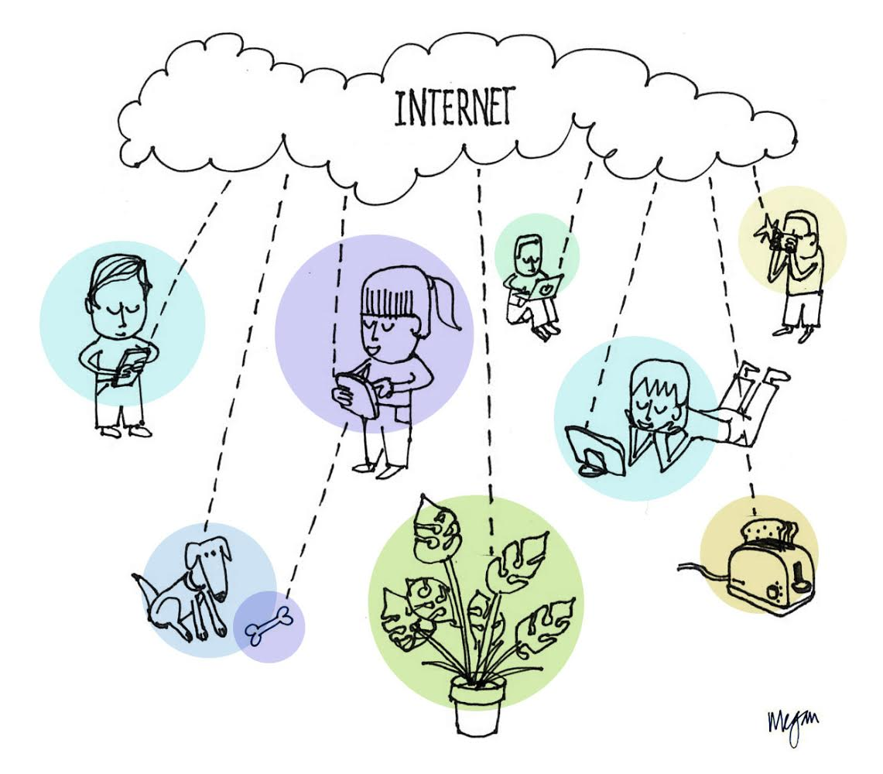

1. What do you understand by Internet? List down your activity you perform in your daily life on Internet.

1. Write at least 3 names of your known people who don’t use Internet.